SmartSimple Log-in Guide

In order to set up an account for a Brain Canada Competition, go on to braincanada.smartsimple.ca.
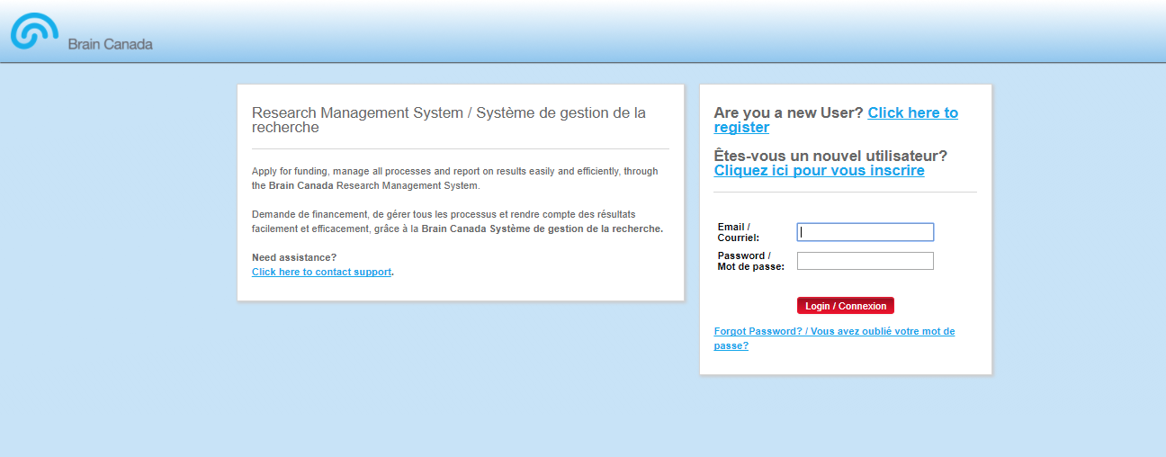

Proceed to fill in your information to register.

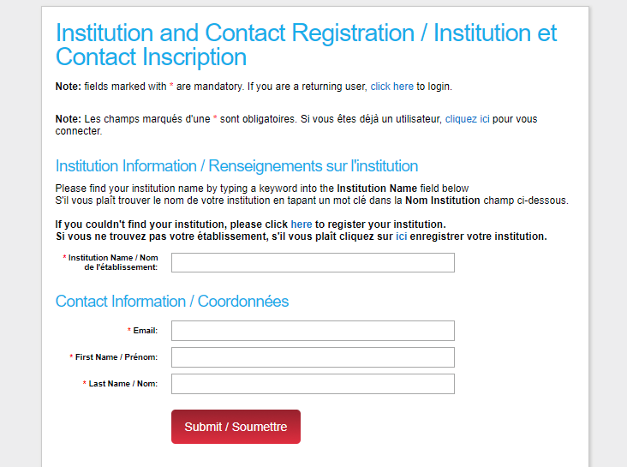

After completing your profile, press the “Funding Programs” icon.

Press “Apply Now” to any Programs that are currently open.

